Inventory
Lower Brule Sioux Tribe Brownfields/Tribal Response Program
(Updated 12/8/20)

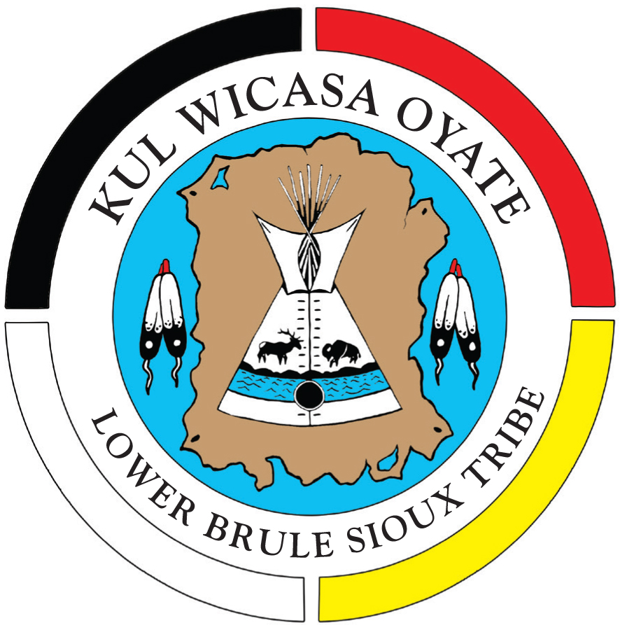

Rodeo Dump
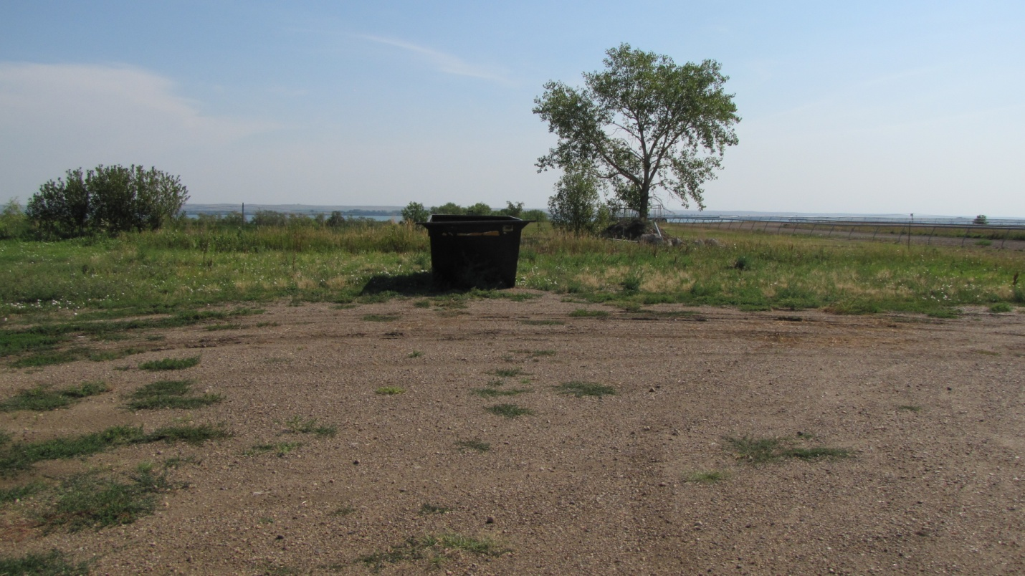
Site Name Rodeo Dump
Current Owner Lower Brule Sioux Tribe
Address Pow Wow Highway
Lat/Long 44 04’ 53 ‘N 99 35’ 03” W
Section 9 Township 107 N, Range 73W
Lyman County, SD

Date of: Phase I September 2004
Phase II September 2005
Phase III November 2006
Phase II July 2011
Suspected Contaminants SVOCs-Herbicides-Pesticides-Total Metals
Hydrocarbons
Institutional Controls None
Site acreage 1.00
Type of Site Old Dump Site
Date Action is Planned Site cleaned up
Kids Pond
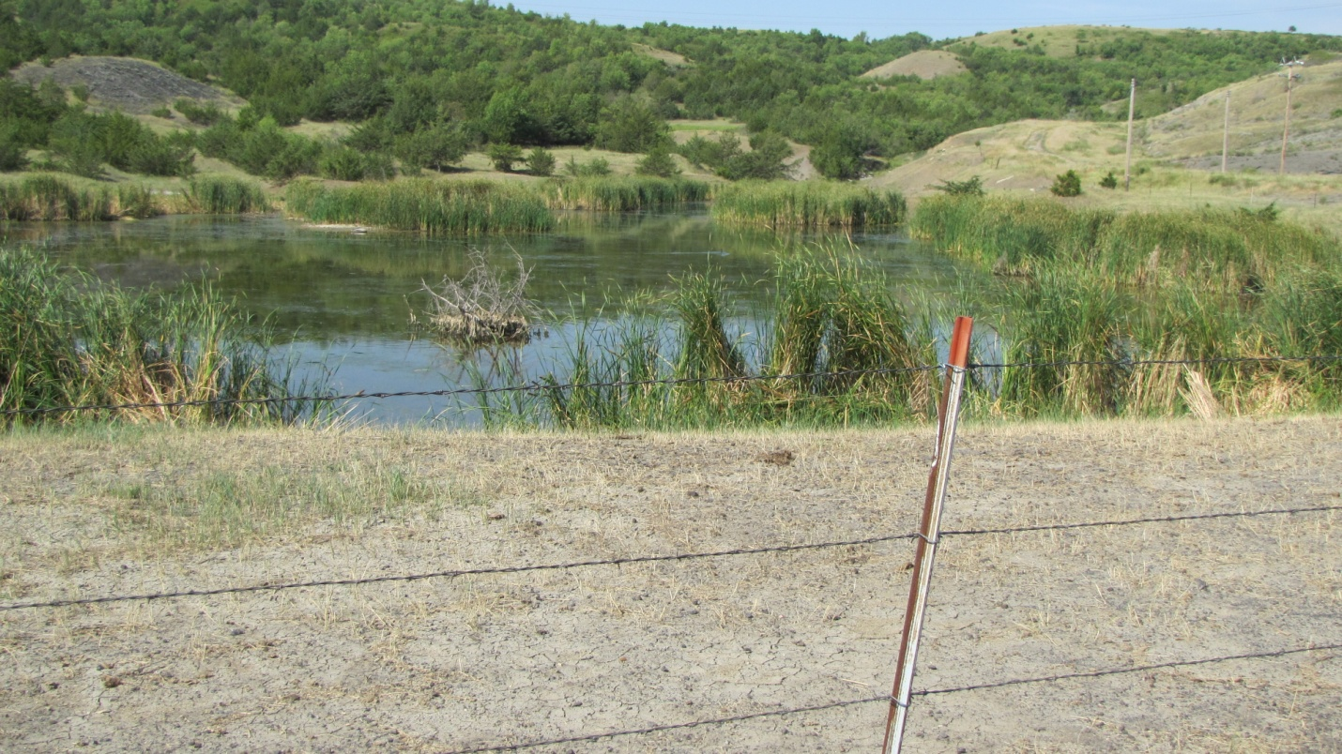

Site Name Kids Pond
Current Owner Lower Brule Sioux Tribe
Address BIA Rt 10 Lower Brule, SD 57548
Lat/Long 44 04’ 18” N 99 35’ 50” W
Section 26 Township 109 N, Range 76W
Lyman County, SD

Date of: Phase I September 2004
Phase II September 2005
Phase III November 2006
Phase II July 2011
Suspected Contaminants VOCs- Chlorinated Herbicides

Institutional Controls Pond is fenced
Site acreage 1.65
Type of Site Old Dump Site
Date Action is Planned Site cleaned up
Old West Brule Dump
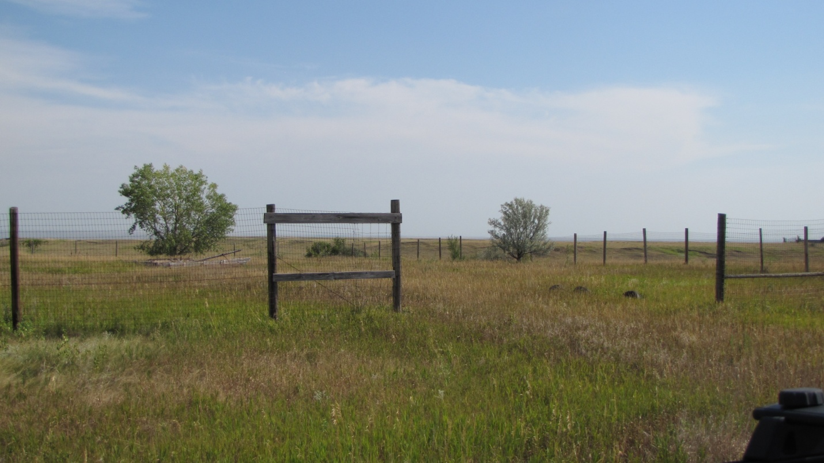
Site Name Old West Brule Dump
Current Owner Lower Brule Sioux Tribe
Address BIA Route 10 Lower Brule, SD 57548
Lat/Long 44.07836 N 99.61294W
T531-2 Lyman County, SD
Date of: Closed 1996
Capped 2003
Phase I May 2003
Phase II Dec 2003
Limited Phase I/Transaction Screen 2013

Suspected Contaminants Low levels- VOCs, SVOC’s, (soil only)
Institutional Controls Site is fenced
Site acreage 10
Type of Site Old Dump Site
Date Action is Planned No further action planned at this time

Old BIA Jail
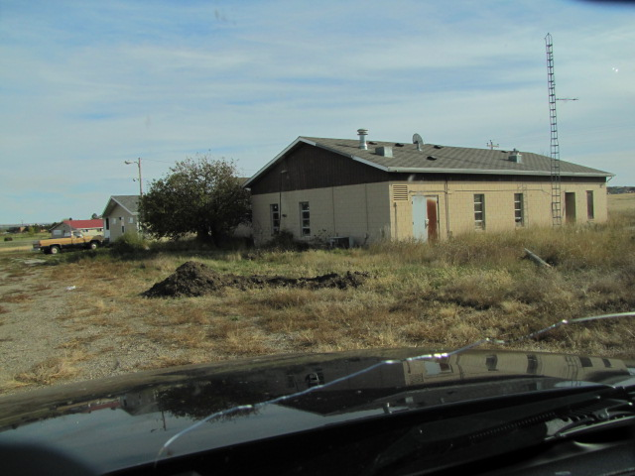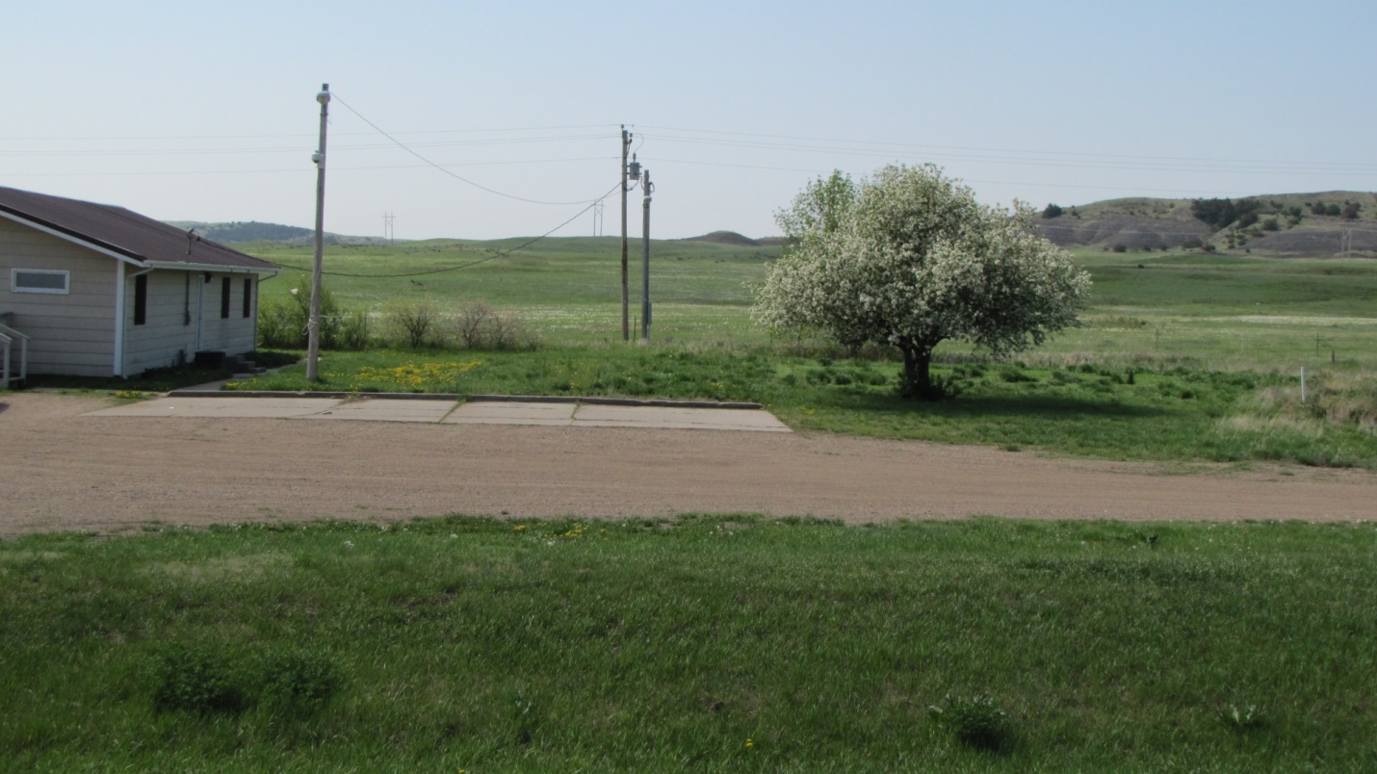

Site Name Old BIA Jail
Current Owner Lower Brule Sioux Tribe
Address BIA Route 10 Lower Brule, SD 57548
Lat/Long 44.067900-44 “4’4.4 N 99.578900-99”34’44.0
Land Description T4079-F Lot 5B WSec. 14, T107N R73W, Lyman County

Date of: Phase I October 2003

Suspected Contaminants Asbestos-Lead based paint
Institutional Controls None
Site acreage 1.1
Type of Site Old Building Site
Date Action is Planned This building was demolished by the LBST and site was
cleaned up

Old BIA Administration Building
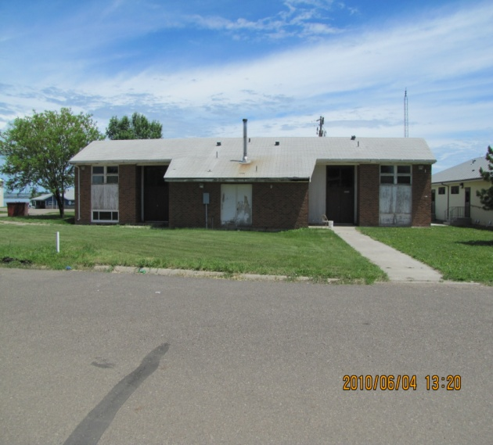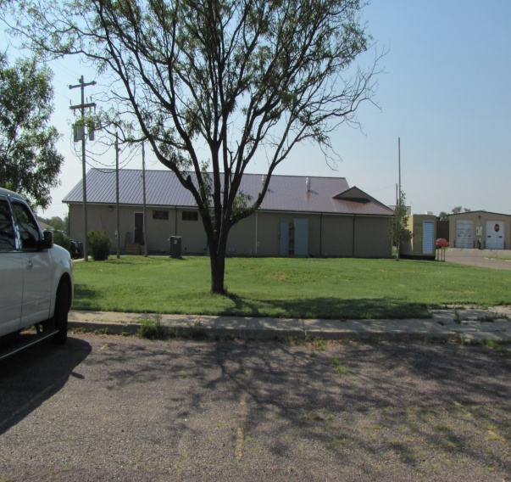
Site Name Old BIA Administration Building
Current Owner Lower Brule Sioux Tribe
Address 90001 Red Cloud Street, Lower Brule, SD 57548
Lat/Long 44 04’ 53 ‘N 9 35’ 03” W
Land Description Section 9. Township 107 N, Range 73W
Lyman County, SD

Date of: Phase I September 2004
Phase II September 2005
Phase III November 2006
Phase II July 2011
Suspected Contaminants SVOCs-Herbicides-Pesticides-Total Metals
Hydrocarbons
Institutional Controls None
Site acreage 1.00
Type of Site Old Dump Site
Date Action is Planned This building was demolished by the LBST and site was
cleaned up

Old Transfer Station
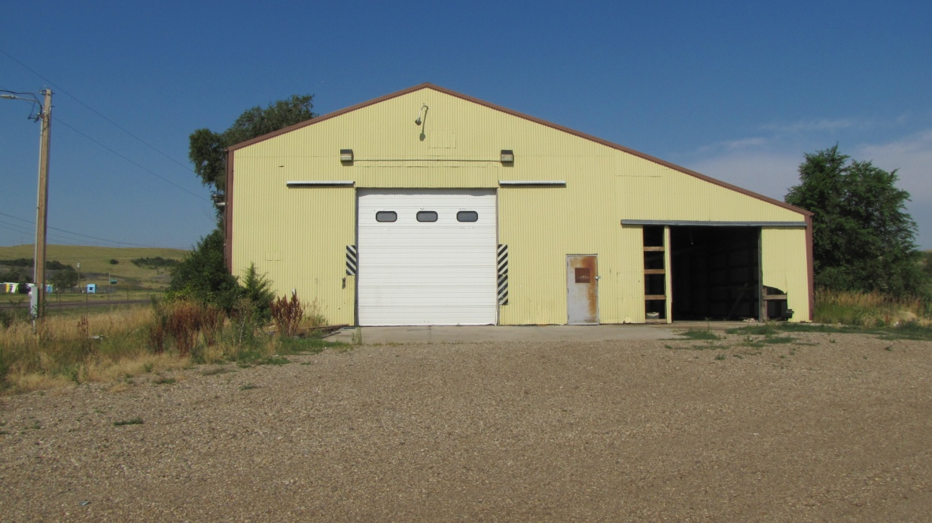

Site Name Old Transfer Station
Current Owner Lower Brule Sioux Tribe
Address Pow Wow Highway Lower Brule, SD 57548
Lat/Long 44. 4’2” N 99.31’52”
Land Description T4079-F Lot 5B WSec. 14, T107N R73W, Lyman County

Date of: Limited Phase I/TS August 2012
Suspected Contaminants
Institutional Controls This building is being used by the Lower Brule
Construction Company to store building materials
Site acreage 2.5
Type of Site Old Transfer Station for Solid Waste Program
Date Action is Planned None

Former Housing Authority Building
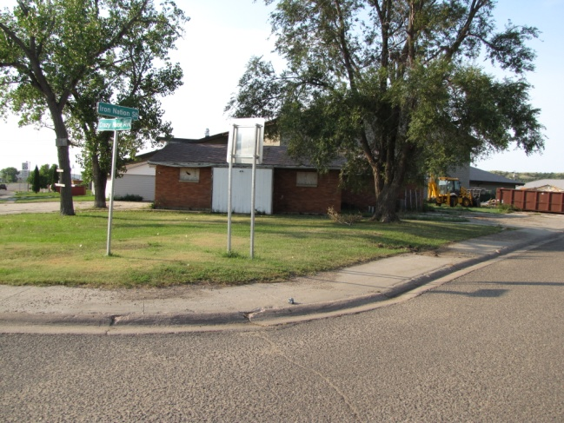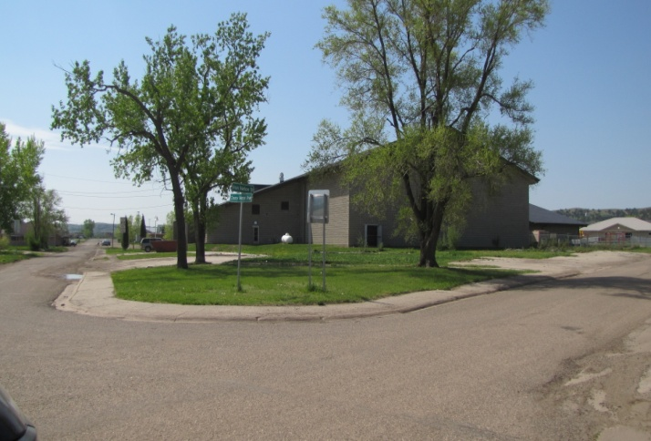
Site Name Former Housing Authority Building
Current Owner Lower Brule Sioux Tribe
Address 633 Crazy Horse Street, Lower Brule, SD 57548
Lat/Long 44. 4’24” N 99.34’42”W
Land Description T4079-F Tract #343-T-343030/T4030-A/T4079-F

Date of: Limited Phase I/TS September 2012
Phase II August 2012
Submitted Cleanup Grant December 2014
Grant Approved May 2015
Cleanup Grant Competed September 2017

Suspected Contaminants Asbestos-Lead-Polychlorinated Biphenyls
Institutional Controls None
Site acreage 0.625
Type of Site Building Site
Date Action is Planned Site cleaned up with Cleanup Grant

Old Diabetic Building
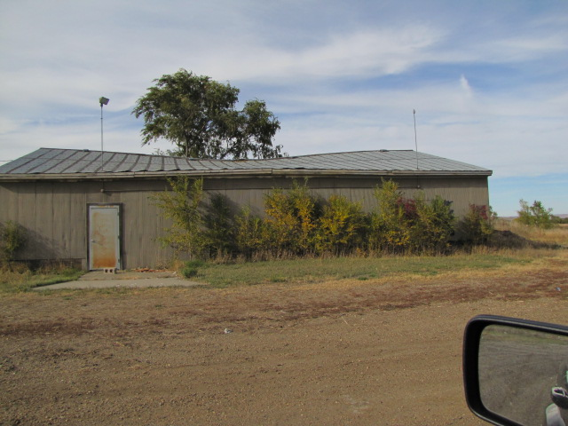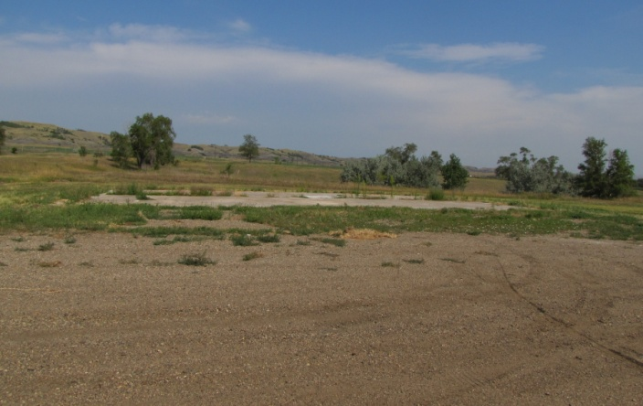

Site Name Old Diabetic Building
Current Owner Lower Brule Sioux Tribe
Address 705 Pow Wow Highway
Lat/Long 44. 4’45.2” N 99.35’14.9”
Land Description T781, NW1/4SW1/4SE1/4SE1/4SE1/1 Sec. 9
T7N,R73W,5Pm

Date of:
Limited Phase I/TS April 2013
Suspected Contaminants
Institutional Controls This building burned down 1-26-13. The tribe
cleaned up the site.
Site acreage 0.625
Type of Site Building Site
Date Action is Planned None

Old Durkin Cure Site
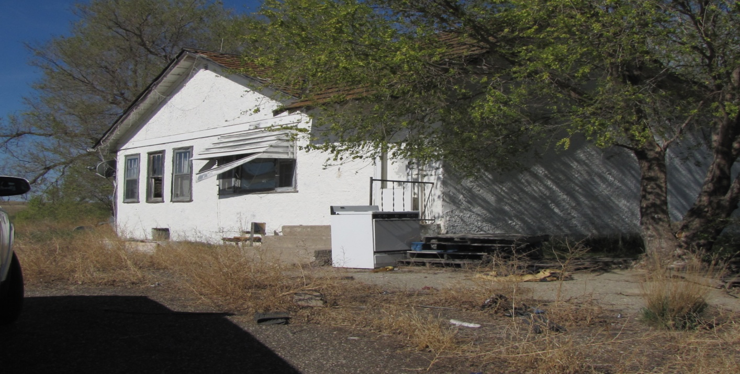
Site Name Old Durkin Curve Site
Current Owner Lower Brule Sioux Tribe
Address 31138 Highway 1806, Lower Brule, SD 57548
Lat/Long 44. 13’20” N 99.55’49”W
Land Description T109N,R76W. 5PM Stanley County

Date of:
Limited Phase I/TS August 2014
Phase II July 2015
Suspected Contaminants ACM, LBP, Lead, Mercury, Mold, Elevated Metals
Institutional Controls Fenced
Site acreage 10
Type of Site Building Site
Date Action is Planned

Sioux Boys Gas Station
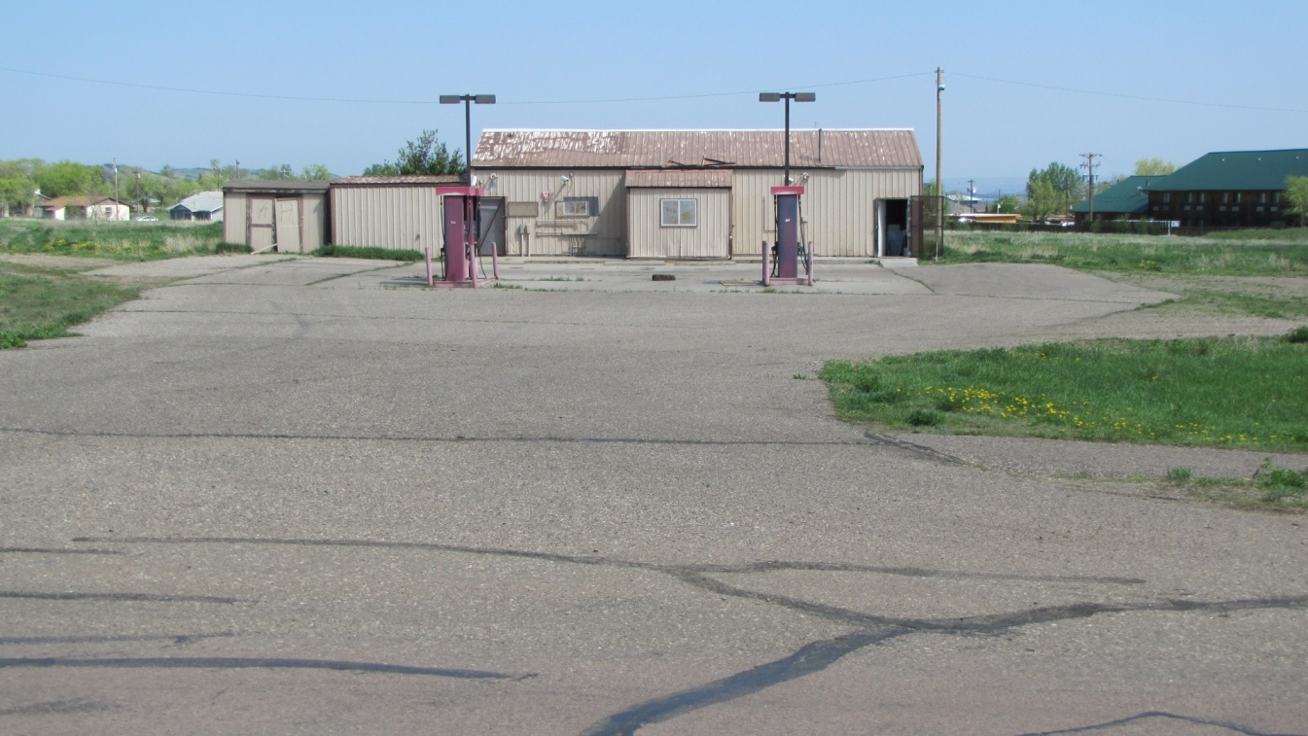

Site Name Sioux Boys Gas Station
Current Owner Stacie Her Many Horses
Address 32908 Iron Nation Road
Lat/Long 44. 069204 99.579083
Land Description

Date of:
Limited Phase I/TS May 2015
Suspected Contaminants Watching the Gas Tanks
Institutional Controls None
Site acreage
Type of Site Gas Tanks
Date Action is Planned None

Thompson Site Fort Hale Bottom
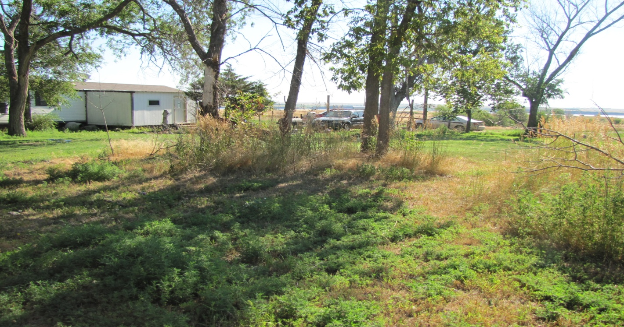
Site Name Thompson Site Fort Hale Bottom
Current Owner Sheldon Fletcher
Address 23561 Fort Hale Bottom Road Reliance SD 57569
Lat/Long
Land Description

Date of:
Limited Phase I/TS February 2016
Suspected Contaminants zinc phosphide
Institutional Controls None
Site acreage
Type of Site
Date Action is Planned None

Old Boys & Girls Club
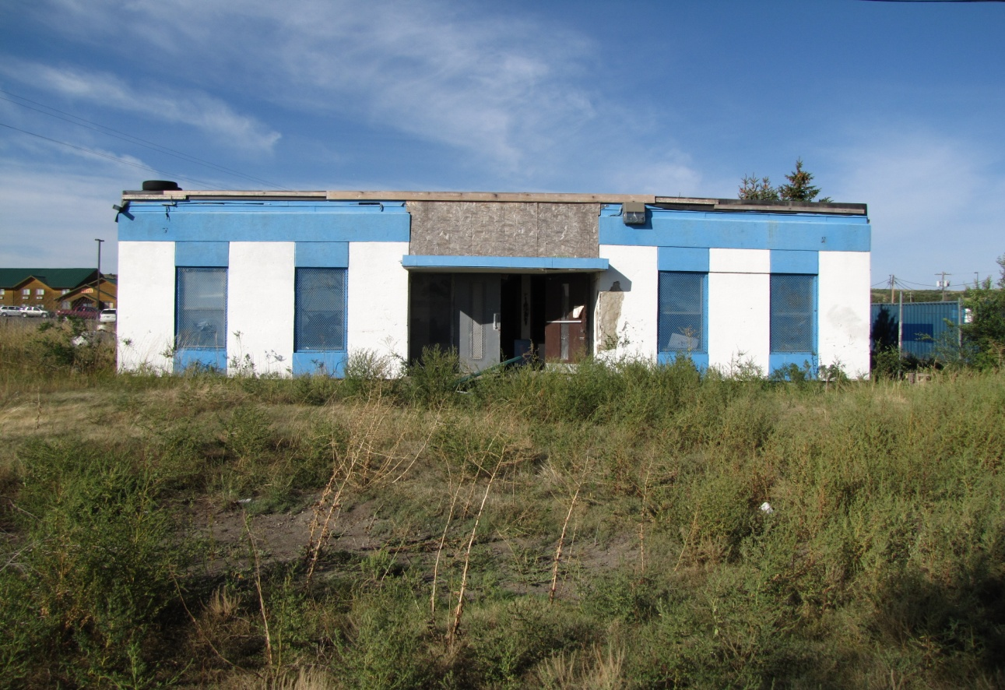

Site Name Old Boys & Girls Club
Current Owner Lower Brule Sioux Tribe
Address 131 Sitting Bull Street, Lower Brule, SD 57548
Lat/Long 44.071914N 99.577600W
Land Description 343 T4030

Date of:
Limited Phase I/TS May 2017
Phase II October 2017

Suspected Contaminants asbestos
Institutional Controls None
Site acreage 0.2
Type of Site Building
Date Action is Planned None
Old Yellow School Buildings
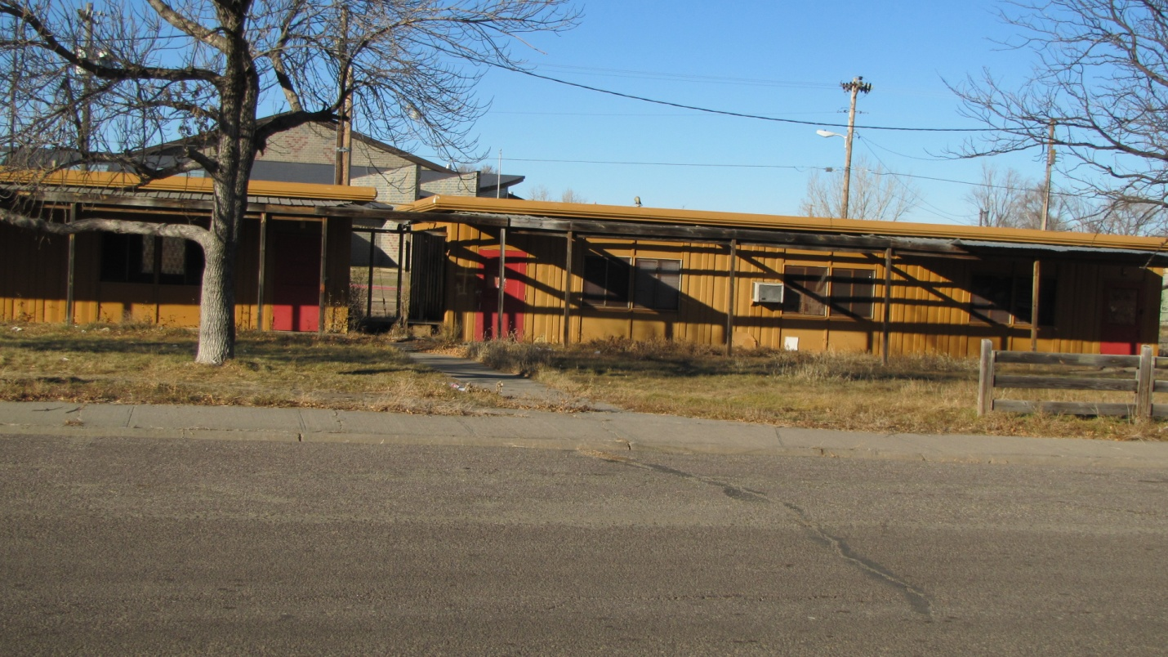

Site Name Old Yellow School Buildings
Current Owner Lower Brule Sioux Tribe
Address 212 Sitting Bull Street, Lower Brule, SD 57548
Lat/Long 44.072040N 99.578727W
Land Description T107N, R73W

Date of:
Limited Phase I/TS June 2017
Phase II October 2017

Suspected Contaminants asbestos, Lead, Mercury, PCBs
Institutional Controls None
Site acreage 0.2
Type of Site Building
Date Action is Planned None

Old Shooting Range
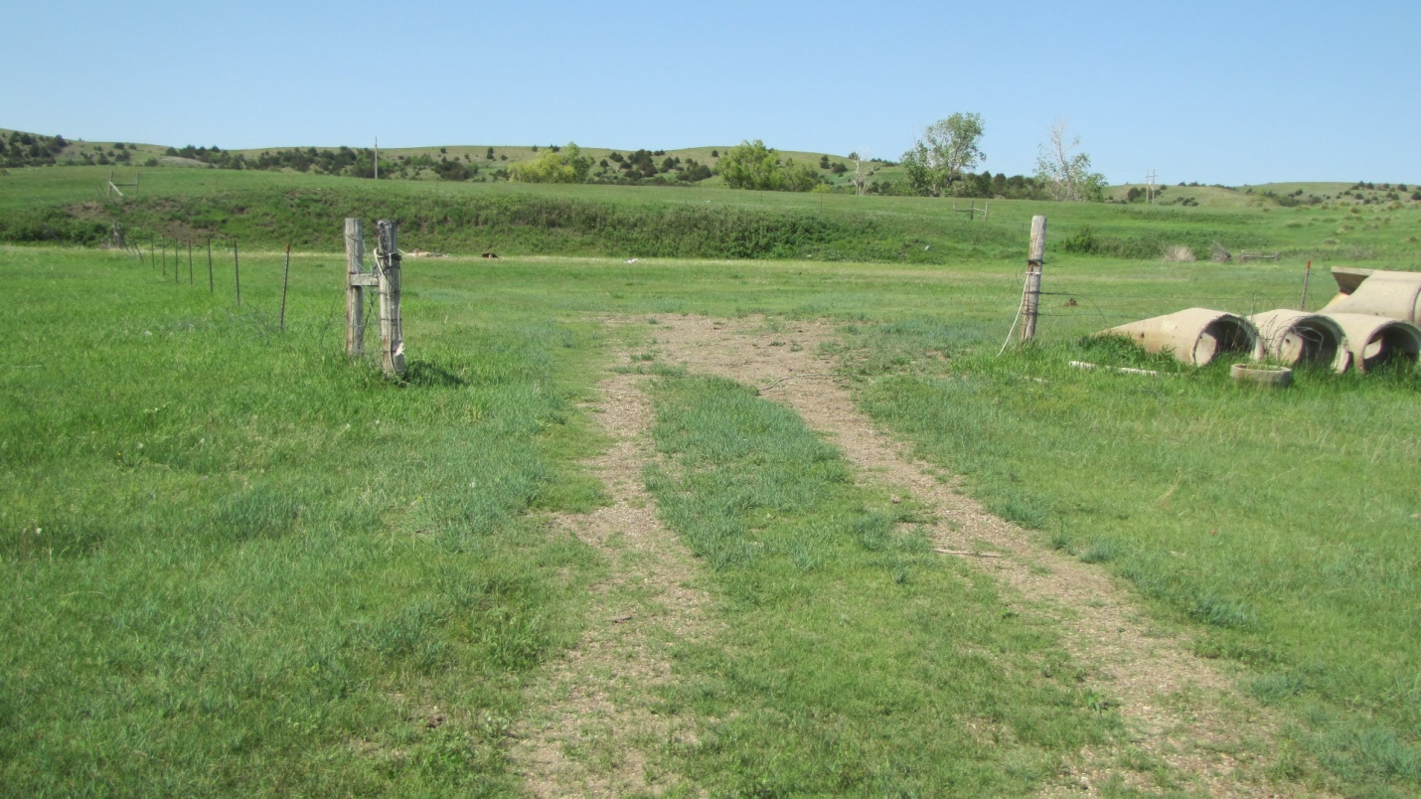

Site Name Old Shooting Range
Current Owner Lower Brule Sioux Tribe
Address BIA 5, Lower Brule, SD 57548
Lat/Long 44. 4’11”N 99.34’42”W
Land Description T107N, R73W

Date of:
Limited Phase I/TS April 2018

Suspected Contaminants Lead
Institutional Controls None
Site acreage 2.5
Type of Site Shooting Range
Date Action is Planned None

Old Durkin Dump

Site Name Old Durkin Dump
Current Owner Lower Brule Sioux Tribe
Address Hwy 1806, Lower Brule, SD 57548
Lat/Long 44. 13’20”N 99.56’31”W
Land Description Section 26 T109N R76W Stanley County

Date of:
Phase I September 2004
Phase II September 2005
Phase III November 2006
Phase II July 2011

Suspected Contaminants
Institutional Controls None
Site acreage 0.85
Type of Site Old Ranch Dump
Date Action is Planned None

#511 Spotted Tail
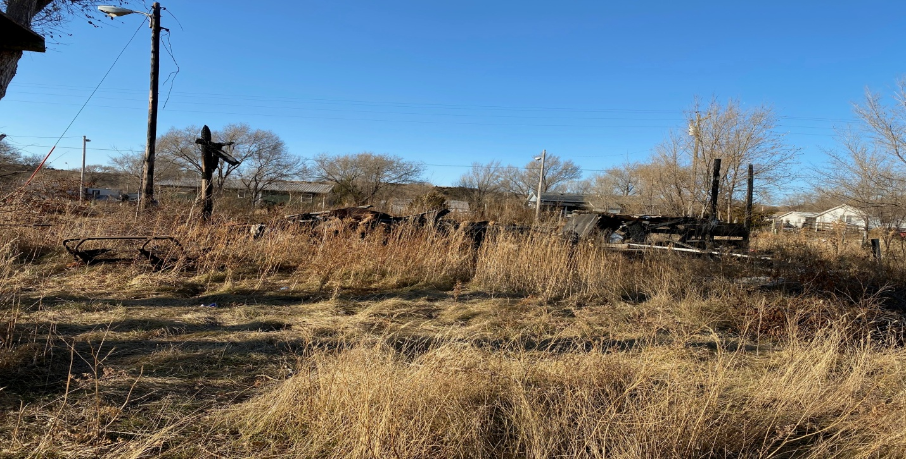
Site Name #511 Spotted Tail
Current Owner Lower Brule Sioux Tribe
Address #511 Spotted Tail St. Lower Brule, SD 57548
Lat/Long 44. 4’23”N 99.34’54”W

Date of:
Suspected Contaminants Asbestos- Lead Based Paint

Institutional Controls none
Site 0.32
Type of Site Old House
Date Action is Planned TBA

#511 Spotted Tail North
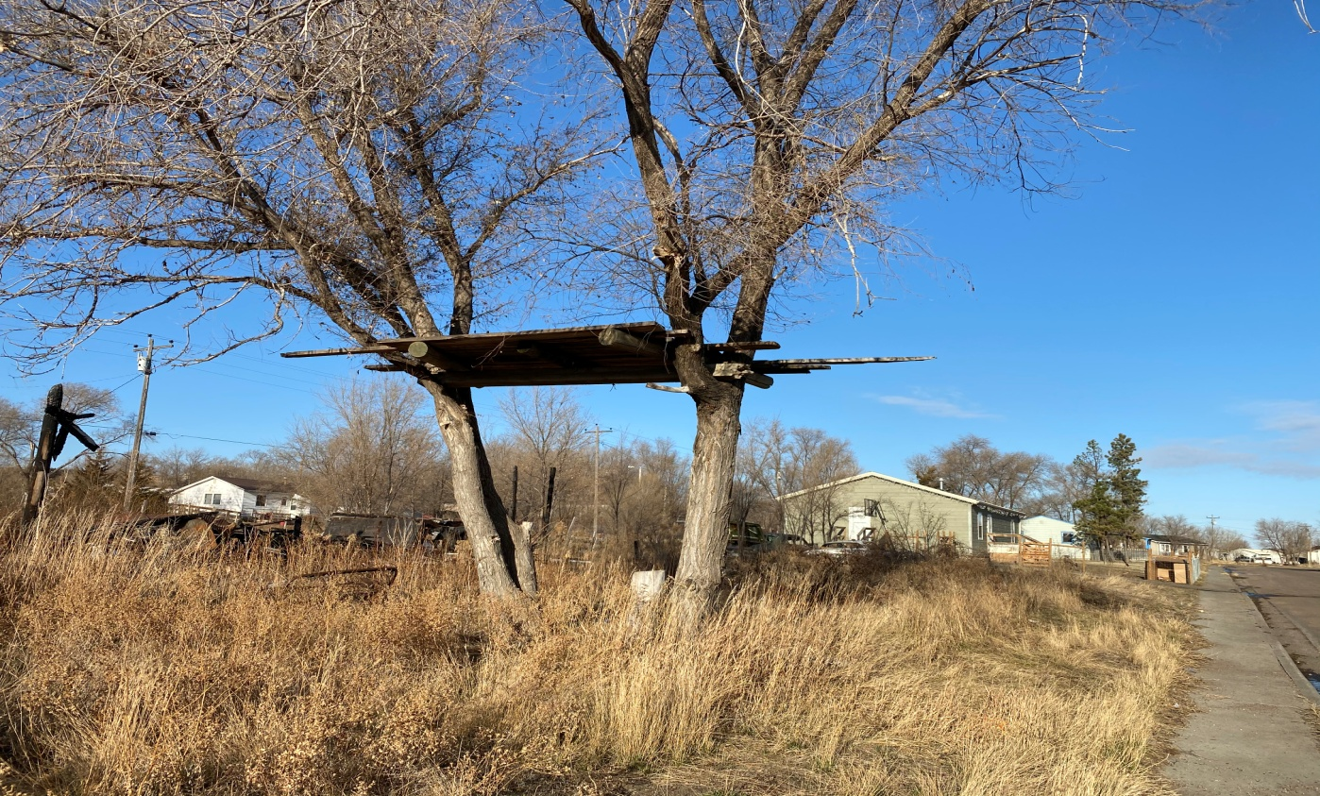
Site Name #511 Spotted Tail North
Current Owner Lower Brule Sioux Tribe
Address #511 Spotted Tail St. Lower Brule, SD 57548
Lat/Long 44. 4’23”N 99.34’53”W

Date of:
Suspected Contaminants Lead Based Paint

Institutional Controls none
Site 0.32
Type of Site old tree house
Date Action is Planned TBA

#240 Spotted Tail
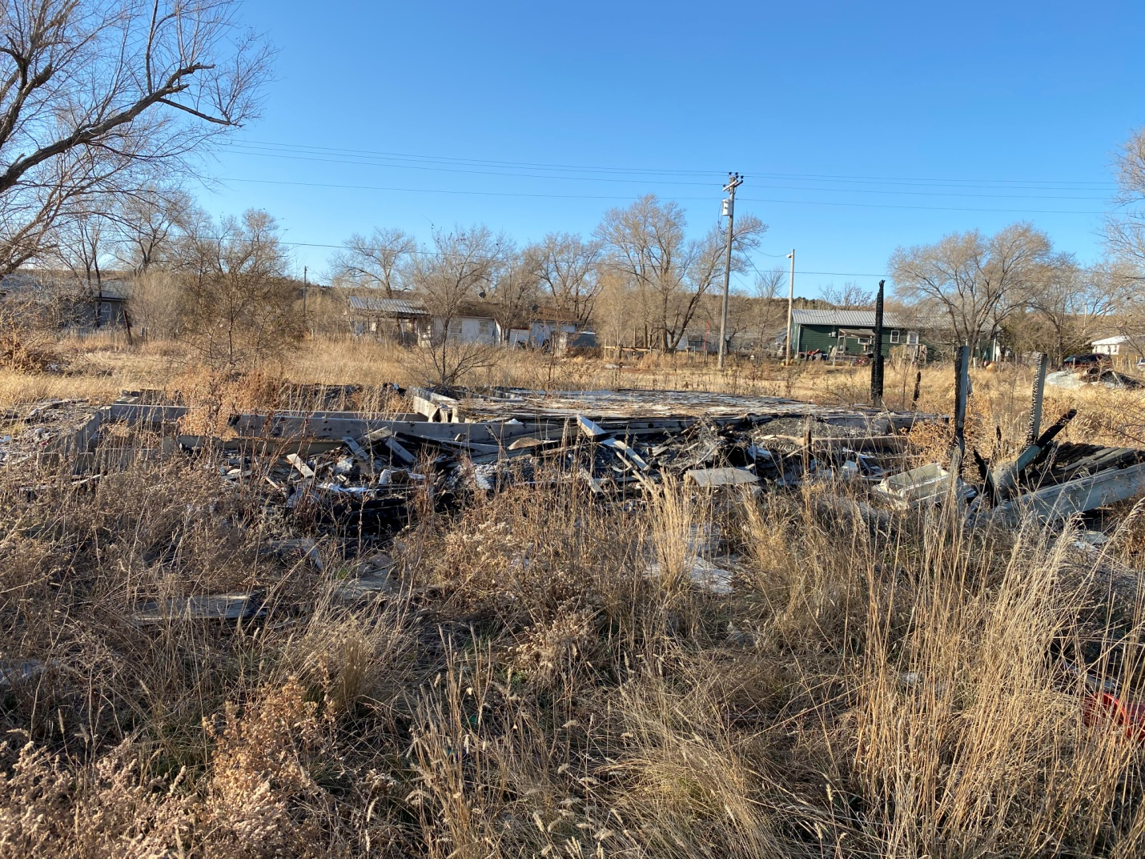
Site Name #240 Spotted Tail
Current Owner Lower Brule Sioux Tribe
Address #240 Spotted Tail St. Lower Brule, SD 57548
Lat/Long 44. 4’23”N 99.34’53”W

Date of:
Suspected Contaminants Asbestos- Lead Based Paint

Institutional Controls none
Site 0.32
Type of Site Old House
Date Action is Planned TBA
#404 Spotted Hawk
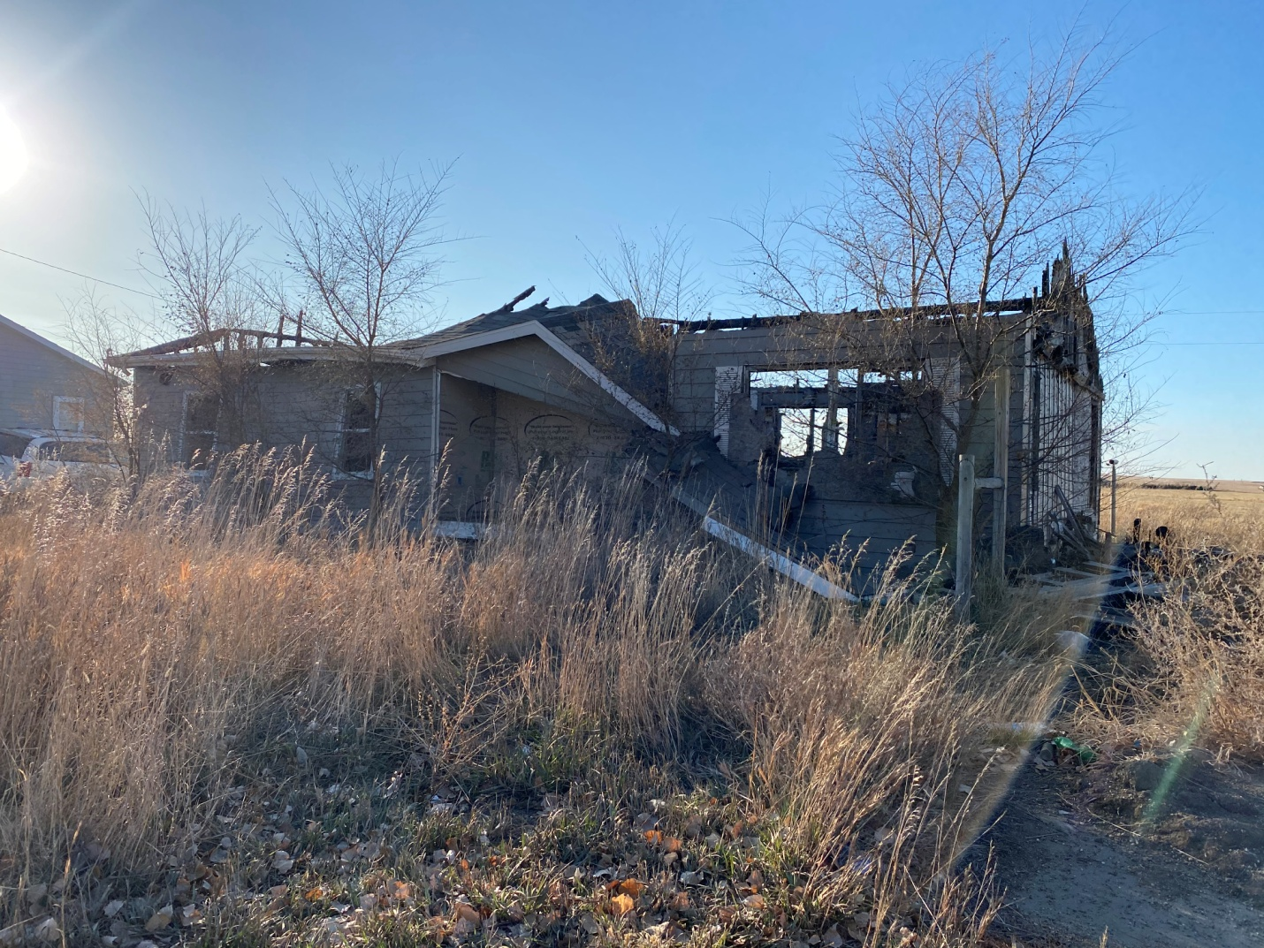
Site Name #404 Spotted Hawk
Current Owner Lower Brule Sioux Tribe
Address #404 Spotted Hawk St. Lower Brule, SD 57548
Lat/Long 44. 4’20”N 99.38’24”W

Date of:
Suspected Contaminants Asbestos- Lead Paint
Institutional Controls none
Site 0.35
Type of Site Old House
Date Action is Planned TBA
#74 Sitting Bull
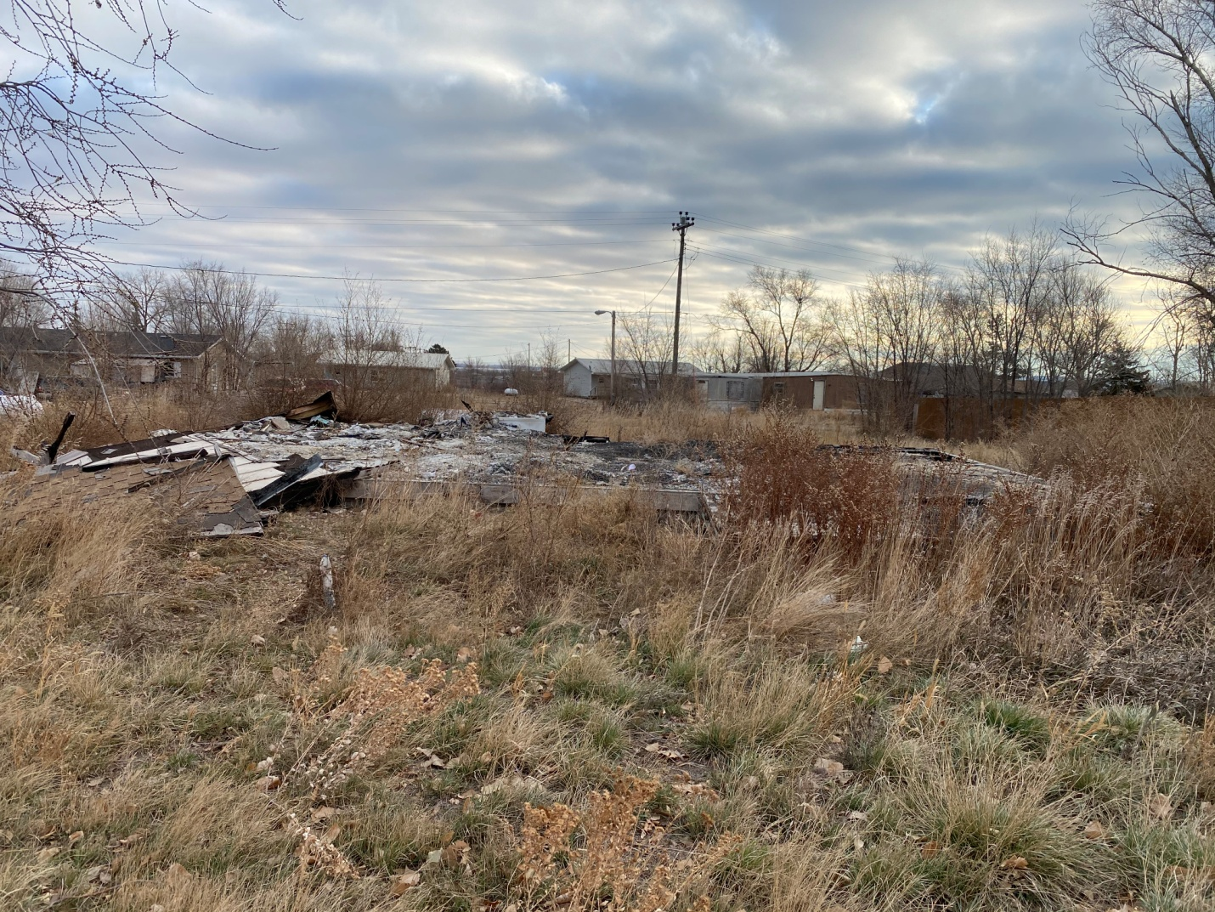
Site Name #74 Sitting Bull
Current Owner Lower Brule Sioux Tribe
Address #74 Sitting Bull St. Lower Brule, SD 57548
Lat/Long 44. 4’27”N 99.34’60”W

Date of:
Suspected Contaminants Asbestos- Lead Based Paint

Institutional Controls none
Site 0.32
Type of Site Old House
Date Action is Planned TBA

